Task on IAM

Task 1: Create one IAM User and assign EC2 and S3 Full Access
Purpose
Create an IAM user with full access to Amazon EC2 and Amazon S3.

Step 1: Login
- Login to AWS Console
- Search IAM
- Open IAM Dashboard

Step 2: Create IAM User
Go to
IAM
→ Users
→ Create user
Enter
User name:
cloud-user
Tick
Provide user access to AWS Management Console
Choose
I want to create an IAM user
Select
Autogenerated password
Click
Next
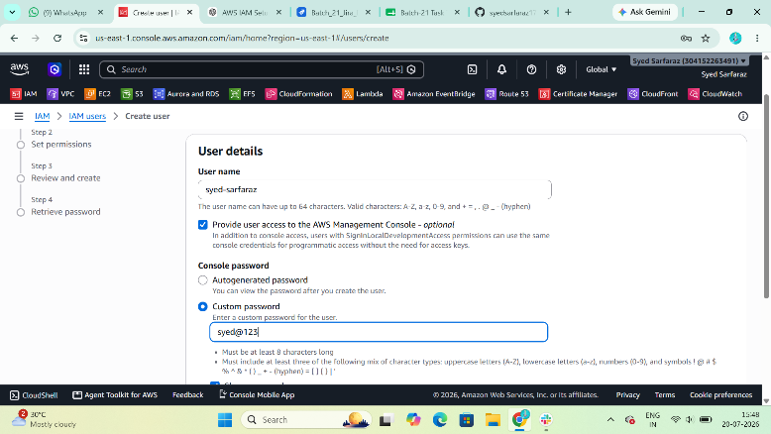

Step 3: Assign Permissions
Choose
Attach policies directly
Search
AmazonEC2FullAccess
Tick it.
Now search
AmazonS3FullAccess
Tick it.
Click
Next
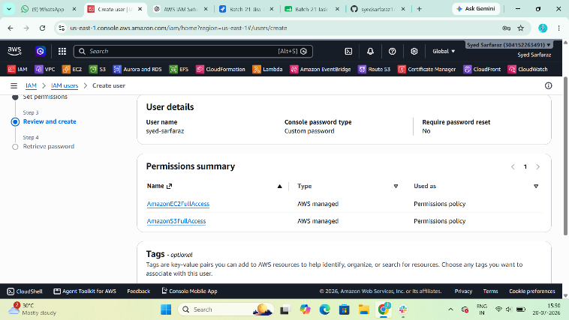

Step 4
Review everything.
Click
Create user
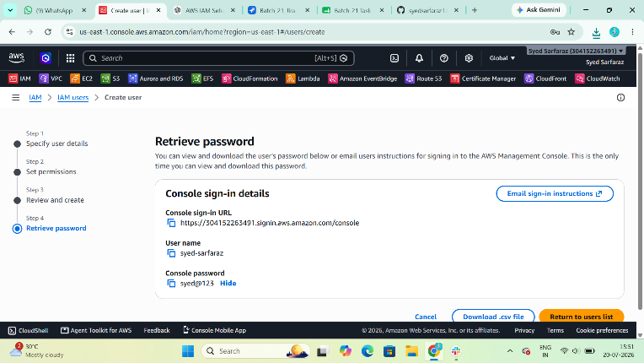

Step 5
Download the credentials
or
Copy
Username
Password
Console Sign-in URL

Task 2: Create one IAM Group and assign EC2 Read Access
Purpose
Create a group that has only EC2 read permissions.

Step 1
Go to
IAM
→ User groups
→ Create group
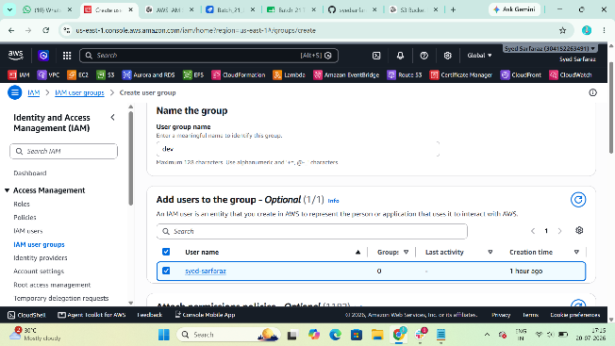

Step 2
Enter
Group name

EC2-ReadOnly

Step 3
Search policy
AmazonEC2ReadOnlyAccess
Tick it.
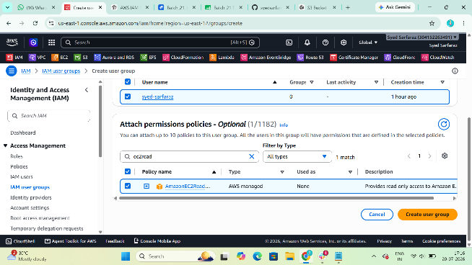

Step 4
Click
Create group
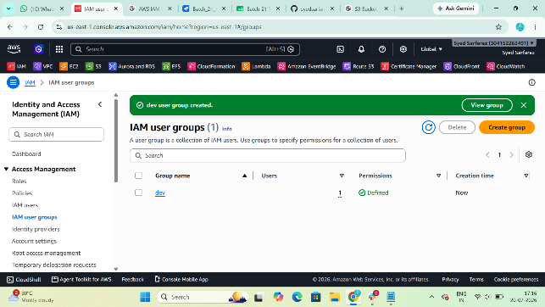

Task 3: Create User "Devops" and add to EC2 ReadOnly Group
Purpose
Create a user with EC2 ReadOnly permissions through the IAM group.

Step 1
Go to
IAM

Users
Create User
Enter
Devops
Enable
AWS Management Console Access
Click
Next
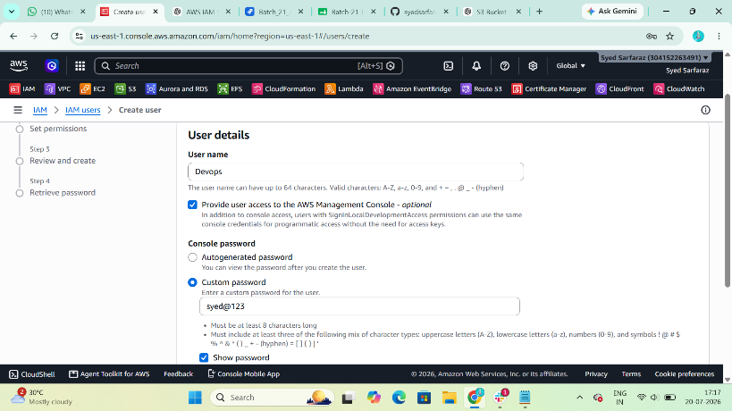

Step 2
Choose
Add user to group
Select
EC2-ReadOnly
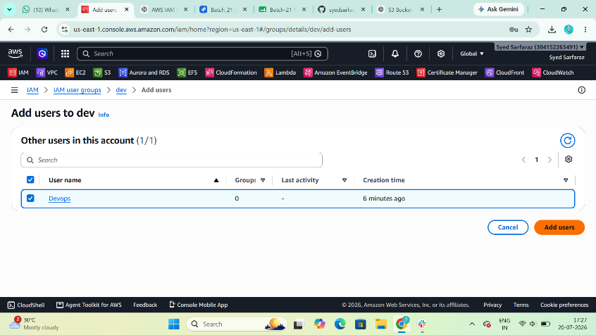
Click
Next
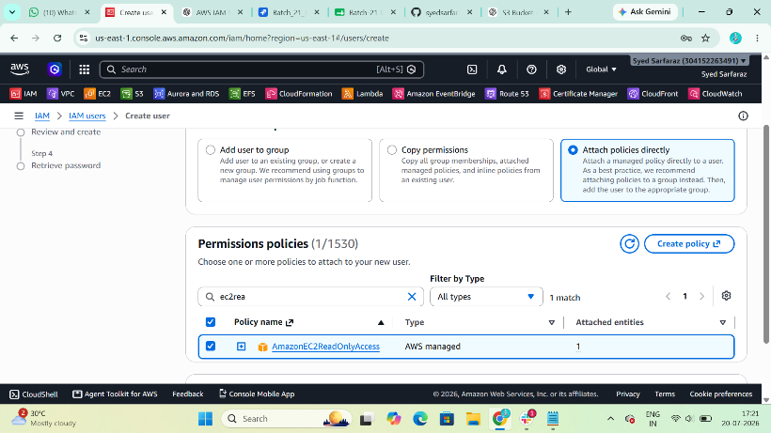

Step 3
Review
Click
Create user
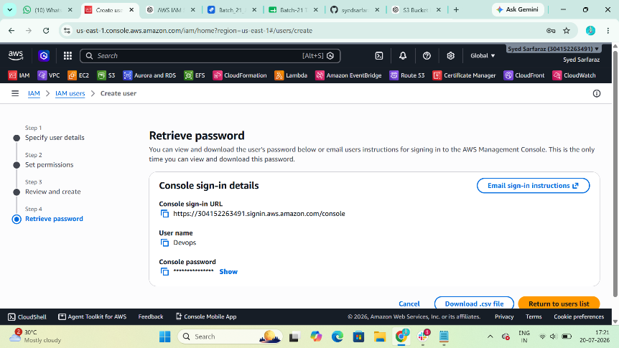

Verify
Open
Users

Devops
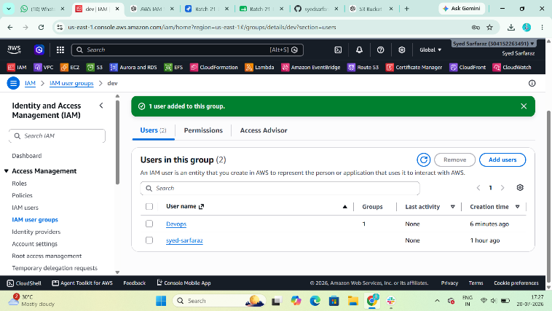
Permissions
You should see
Inherited from group

EC2-ReadOnly

Task 4: Bash Script to Create IAM User with VPC Full Access
Purpose
Automatically create an IAM user and assign VPC Full Access.

Prerequisites
Install AWS CLI
Configure AWS CLI
aws configure
Enter
Access Key
Secret Key
Region
Output format
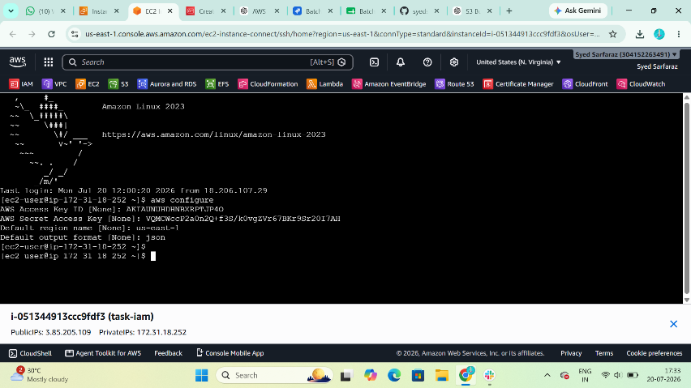
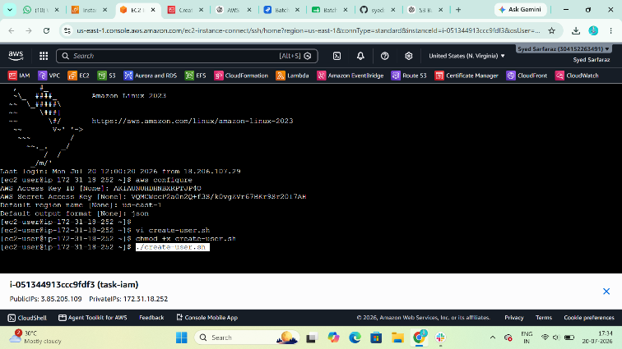

Create Script
vi create-user.sh
Paste
#!/bin/bash

USERNAME="vpc-user"

aws iam create-user --user-name $USERNAME

aws iam attach-user-policy \
--user-name $USERNAME \
--policy-arn arn:aws:iam::aws:policy/AmazonVPCFullAccess

echo "User Created Successfully"
Save
:wq
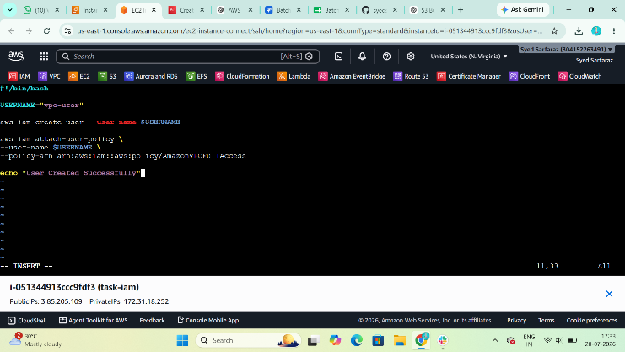

Give Execute Permission
chmod +x create-user.sh

Execute
./create-user.sh
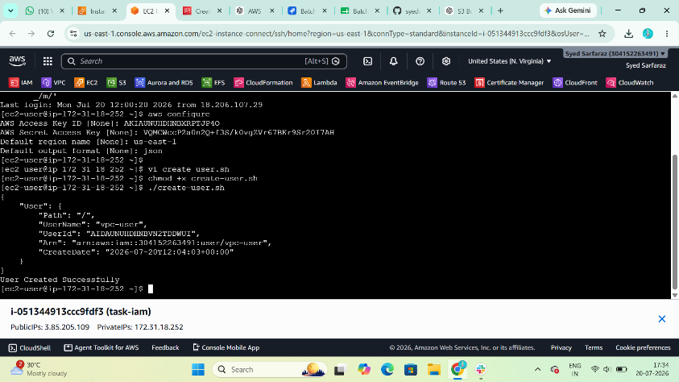

Verify
Go to
IAM

Users

vpc-user
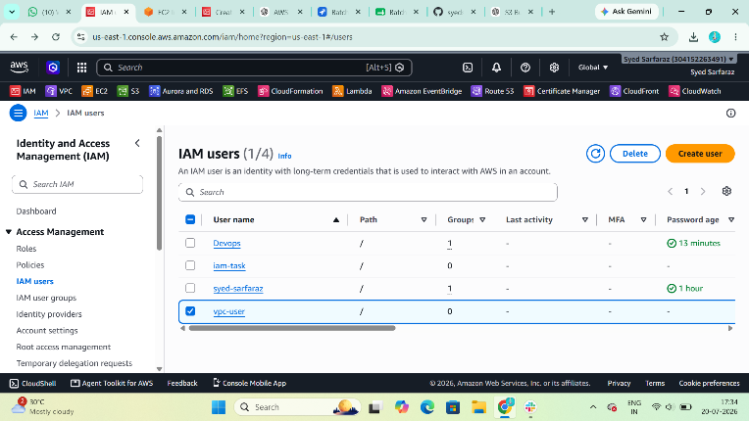

Permissions
You should see
AmazonVPCFullAccess
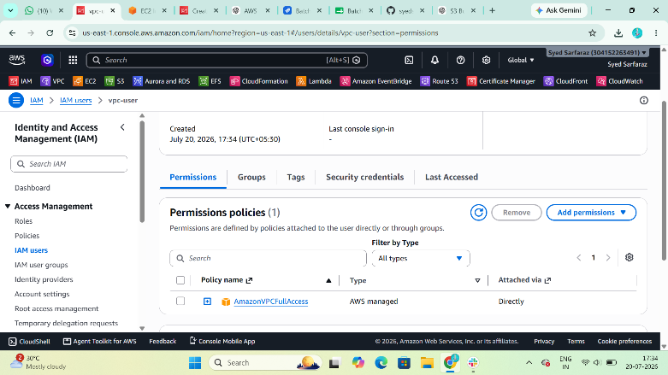

Task 5: Create IAM Policy allowing EC2 access only in Specific Region
Example Region
ap-south-1
(You can change it to us-east-1 if required.)

Step 1
Go to
IAM

Policies

Create policy
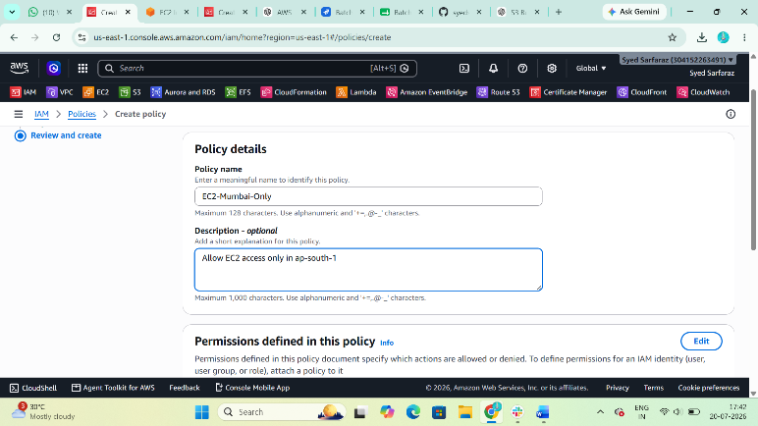

Step 2
Choose
JSON
Paste
{
"Version": "2012-10-17",
"Statement": [
{
"Sid": "EC2OnlyInMumbai",
"Effect": "Allow",
"Action": "ec2:*",
"Resource": "*",
"Condition": {
"StringEquals": {
"aws:RequestedRegion": "ap-south-1"
}
}
}
]
}
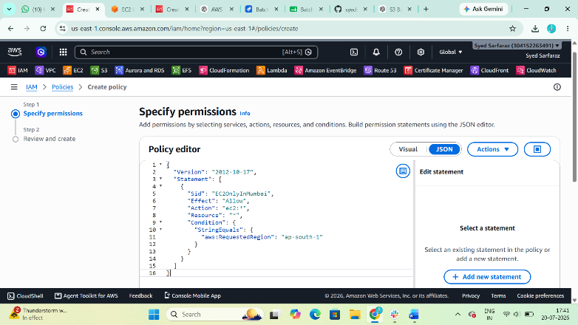

Step 3
Click
Next
Policy Name
EC2-Mumbai-Only
Description
Allow EC2 access only in ap-south-1
Click
Create Policy

Step 4
Attach Policy
Go to
IAM

Users

Select User

Add Permissions

Attach Policies
Select
EC2-Mumbai-Only
Click
Add Permissions
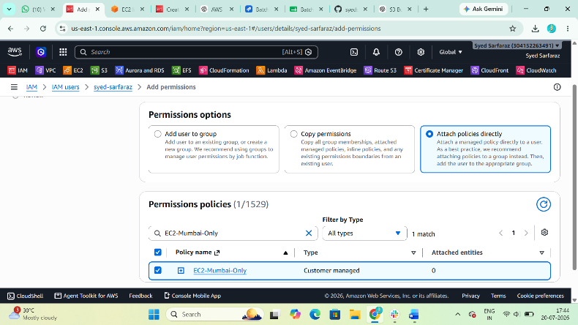

Task 6: Cross Account S3 Access (Account A → Account B)
This is a common interview scenario.

Scenario
Account A
↓
IAM User
↓
Access
↓
S3 Bucket
↓
Account B

Step 1 (Account B)
Login to
Account B
Create S3 Bucket if not already created.
Example
company-backup-demo

Step 2 (Account A)
Open
IAM

Users

cloud-user
Copy the Account A AWS Account ID (or note the IAM user's ARN if your instructor specifically asks to grant a single user).
Example Account ID:
111122223333

Step 3 (Account B)
Open
S3

company-backup-demo

Permissions

Bucket Policy
Edit
Replace 111122223333 with the actual Account A AWS Account ID and replace cloud-user with the actual IAM user name if using the user ARN.

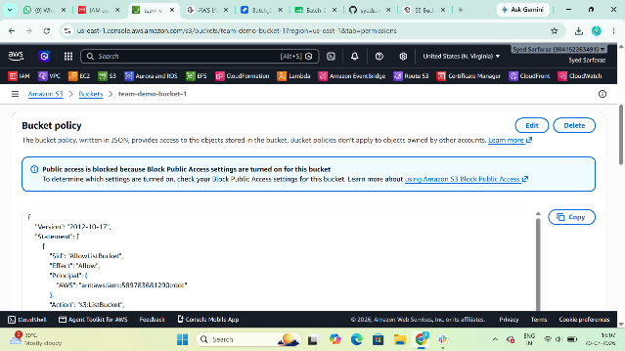
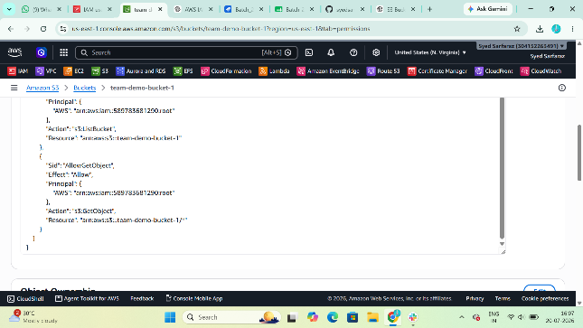

bucket policy:
{
"Version": "2012-10-17",
"Statement": [
{
"Sid": "AllowAccountAUser",
"Effect": "Allow",
"Principal": {
"AWS": "arn:aws:iam::111122223333:user/cloud-user"
},
"Action": [
"s3:ListBucket",
"s3:GetObject",
"s3:PutObject"
],
"Resource": [
"arn:aws:s3:::company-backup-demo",
"arn:aws:s3:::company-backup-demo/*"
]
}
]
}
Click
Save changes

Step 4 (Account A)
Attach an IAM policy to cloud-user that allows S3 access to the bucket.
Go to
IAM

Users

cloud-user
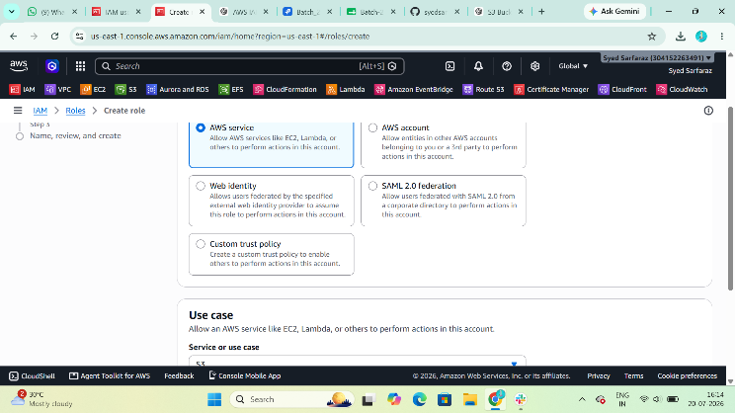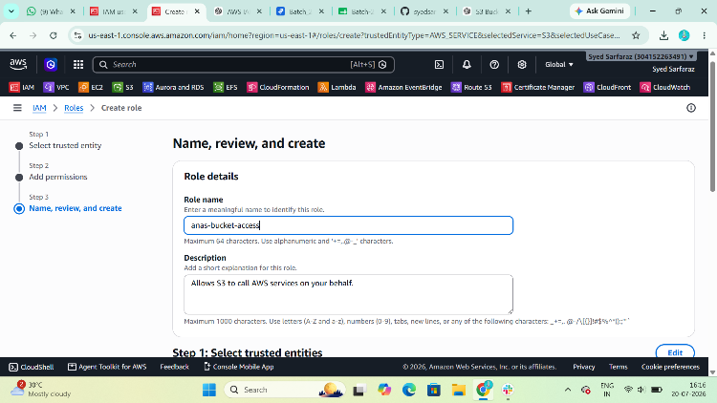
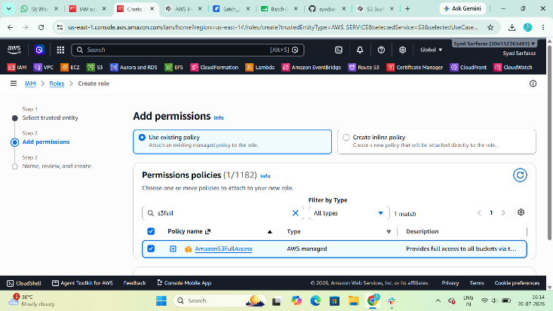
Add Permissions

Create Inline Policy
Choose JSON and paste:
{
"Version": "2012-10-17",
"Statement": [
{
"Effect": "Allow",
"Action": [
"s3:ListBucket",
"s3:GetObject",
"s3:PutObject"
],
"Resource": [
"arn:aws:s3:::company-backup-demo",
"arn:aws:s3:::company-backup-demo/*"
]
}
]
}
Save the policy.
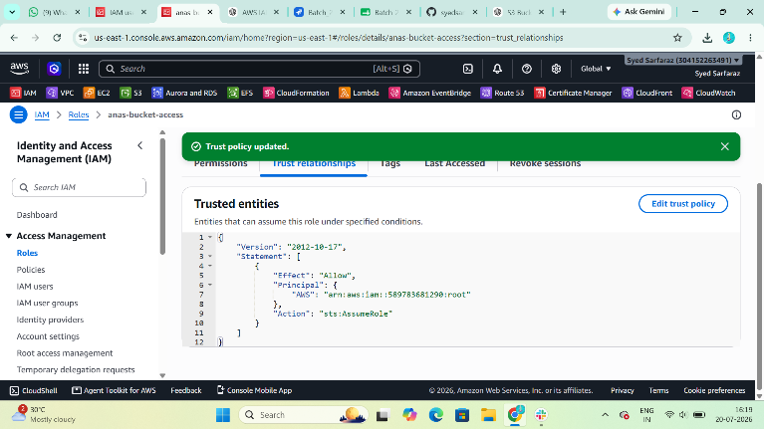

Step 5: Test Access
Sign in as the cloud-user from Account A and access the bucket company-backup-demo in Account B. Verify that you can list the bucket and upload/download objects.
